Research Report

“How does the emotional factor of fear influence misinformation sharing among MAGA communities on X”

BY MINGJUN LIU 1441230

Word count: 2719 words (excluding references & appendix)
Researching Audiences and Reception (MECM40003)
University of Melbourne | Semester 1, 2025

Abstract
This study investigates how fear, as a central emotional driver, shapes the sharing of misinformation within MAGA communities on X (formerly Twitter). While prior research has addressed political polarisation and misinformation, fewer studies explore how affect—especially fear—structures users’ interpretive logics and everyday media practices. This project addresses that gap through a qualitative case study based on a semi-structured interview with one politically engaged user.
Guided by Lifeworld theory (Habermas) and supported by Affective Publics (Papacharissi), Social Identity Theory, and Uses and Gratifications theory, the research develops a multidimensional framework for understanding emotion-driven media engagement.
Findings show that fear doesn’t work as a paralysing trait but rather as an emotional watchtower that, on the one hand, confirms the in-group identity, legitimises suspicion towards institutions, and, on the other hand, brings sharing as a civic practice in the front of the stage. The reframing of misinformation is not that of falsehood, but of emotionally true content in a morally saturated lifeworld.
The study highlights the limitations of rationalist, fact-based interventions and the necessity of engaging more fully with the affective infrastructures that animate digital belief systems, identity construction and political mobilisation..

Content Page
Abstract 2
Introduction 1
Literature Review 2
1. Affective Publics and the Politics of Fear 2
2. The Lifeworld and Subjective Meaning-Making 2
3. Social Identity, Emotion, and Group Solidarity 3
4. Uses and Gratifications: Emotional Needs and Media Practice 3
Methodology 4
Interpretation 5
Level 1: Overall Experience and Practice 5
Level 2: Nuances of Practice 7
Level 3: Subjective Theme Based on Subjective Experience 8
Conclusion 9
Reference 11
Appendix 12
A. Key sections from interview & Interview questions 12
B.Plain Language Statement 17
C.Consent form 19

Introduction
At a time when computer code has become wild and when political divisions grow deeper, platforms like Facebook and Twitter are as much about emotion as anything. Especially in ideologically predisposed circles, spaces like X (née Twitter) do not serve merely as conduits for information, but as affective environments in which users form identities, build affiliations with groups and react to threats with gut-level panic. The present study examines the role of fear in the communication of misinformation in MAGA (Make America Great Again) groups on X, and how it is lived, interpreted and mobilized through the practices of everyday users.
Even as the majority of misinformation literature centers around cognitive bias, ideological correspondence, or media literacy, there are relatively few studies that take into account the emotional logics—most notably, fear—that underpins consumption of false or unverifiable information. The project fills this research gap by reimagining misinformation as an affectively salient feature grounded in the digital lifeworlds of its users rather than merely as a distortion of fact. Instead of seeing the consumption of misinformation as passive or irrational, the present work examines how this content resonates at an affective level, serving to consolidate in-group solidarity and symbolic action.
Following Lifeworld theory (Habermas, 1981), this study treats digital platforms as spaces in which meaning is made by individuals in routinised, affective practices. This conceptual kernel is developed around Papacharissi’s (2015) framework of the Affective Publics and emotional expression organizes digital publics; Social Identity Theory (Tajfel & Turner, 1979) which explains how in-group validation and perceived threats drive emotional responses; and Uses and Gratifications which reflects emotionally motivated media use.
Using a qualitative, semi-structured interview with a MAGA-aligned X user, this study investigates how fear becomes a mode of knowing—how it guides belief, sharing behavior, and collective interpretation. The aim is not to quantify misinformation, but to understand how it becomes emotionally powerful and socially productive within affective digital communities. In doing so, the project contributes to a growing body of scholarship that sees misinformation not simply as a failure of truth, but as a vehicle for emotionally charged meaning-making in an increasingly unstable media landscape.

Literature Review

Affective Publics and the Politics of Fear
- Scholars have increasingly acknowledged emotion as central to digital discourse. Papacharissi (2015) conceptualises affective publics as networked collectives that mobilise not through deliberation but shared emotional intensities. Unlike the rationalist ideals of the Habermasian public sphere, affective publics function through resonance, ambient affiliation, and the viral circulation of sentiment. Within these spaces, fear serves as a potent cohesive force—it sustains group identity, validates dominant narratives, and accelerates the spread of emotionally charged content.
Ahmed (2014) complements this view by theorising fear as socially generative. In The Cultural Politics of Emotion, she argues that fear circulates through bodies and texts, attaching itself (“sticking”) to figures and symbols of threat. For MAGA communities, fears of institutional betrayal or cultural decline become structuring affects that define not only political orientation but everyday engagement with content.

The Lifeworld and Subjective Meaning-Making
- Habermas’s (1981) theory of the lifeworld constructs communication as situated in commonly shared cultural horizons and assumptions. In digital settings, the lifeworld has become mediated, with platforms such as X shaping the backdrop of sorts through which users perceive credibility, risk, and community. As Morimoto and Friedland (2010) contend, political media users do not only consume media, they experience it. Within this affective lifeworld locus, users experience fear which emerges as the lens through which content information is decoded as well as the shape of what reality presents.
Under this aspect, misinformation does not get judged by the facticity, but the coherence with emotional/communal logics. Instead, content that is ostensibly false can still “make sense” when it is organized within the emotional grammar of a fear-filled lifeworld.

Social Identity, Emotion, and Group Solidarity
- Social Identity Theory (Turner & Tajfel, 1979) provides insights into how people derive their sense of self from membership in groups. On the internet, expressions of fear like these help strengthen and differentiate an in-group. In MAGA’s pegasus brigades, scared-as-you-go stories — about election fraud or border vulnerability — do more than simply convince people, they affirm identity..
Marwick and Lewis (2017) argue that ‘“Fake news” does not refer to factually inaccurate information that causes harm,” but rather “to information that is spread with the intention to mislead in the name of making profit or (more rarely) for political gamesmanship’ (p. 8) 2 and ‘feels true’ in an emotion-bonded collective. This “emotional truth effect” is heightened in context of low trust in institutions and high symbolic belonging — a configuration common to polarised online publics.

Uses and Gratifications: Emotional Needs and Media Practice
- Although early U&G work focused on information or entertainment needs, current work has embraced emotion as an impetus for media use. Sundar and Limperos (2013) also point out that digital affordances allow affective pleasures, and Perks and Turner (2019) note that people often seek out content that produces affective stimulation, caress, or validation. For MAGA users such as Daniel, the fear-soaked content might serve not just as political commentary but “as emotionally import “stuff” to use for their [sense of belonging through vigilance, their sense of communally meaningful self-expression through resistance.
Together, these frameworks demonstrate that misinformation is not merely a matter of distorted facts or ideological manipulation—it must be understood within the affective and social environments that give it meaning. Despite growing literature on either emotion or misinformation, few studies critically examine how fear operates as a lived, emotionally structured logic within politicised digital lifeworlds. This research directly addresses that gap, investigating how one MAGA-aligned user experiences, interprets, and circulates fear as a meaningful—if contested—response to perceived crisis.
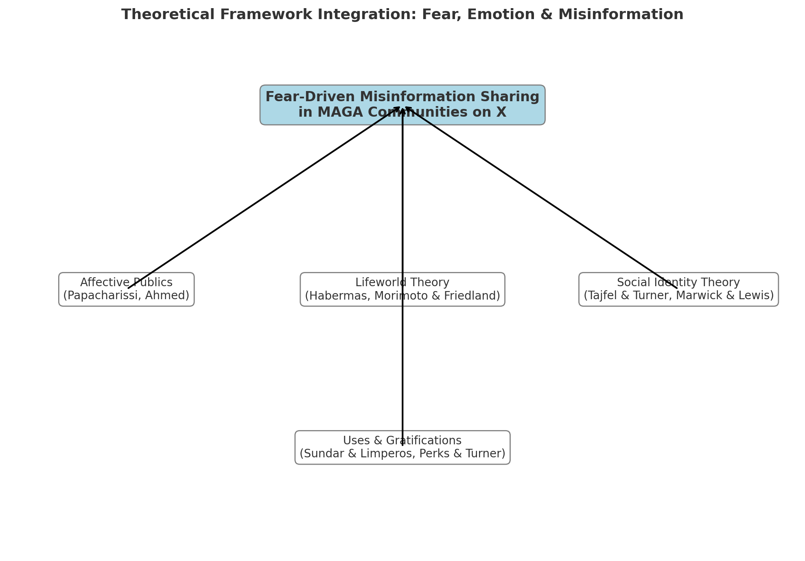

Methodology
This study adopts a qualitative, interpretive approach to examine how fear shapes misinformation sharing within MAGA communities on X (formerly Twitter). Rather than pursuing generalisable claims or causal explanations, it seeks to uncover the subjective logic, affective motivations, and meaning-making processes embedded in one user’s digitally mediated lifeworld.
The study is based on Lifeworld theory (Habermas, 1981) that understands everyday communication to be structured by common cultural assumptions and emotional attitudes. In a platform-dense media world, spaces like X do more than convey information — they cultivate an emotional frame, an identity boundary, a moral requirement. This model is grounded in the work of Papacharissi’s (2015) Affective Publics, which describes how emotions galvanise digital publics; Social Identity Theory (Tajfel & Turner, 1979), which shows how in-group identity functions affectively; and Uses and Gratifications (Sundar & Limperos, 2013), providing a theory of affect-driven media use.
We conducted one semi-structured, in-depth interview (n=1) with a purposefully selected participant who was a 25-year-old US-based postgraduate student, politically conservative, and a MAGA-embedded active user in X communities. The interview took place on Zoom on May 25, 2025, and lasted 45 minutes. Such a format enabled thematic coherence as well as the flexibility to track with the participant’s narrative, especially in regard to affective experiences, misbeliefs, and practices of sharing.
Driven by a hermeneutic approach, the interview was then transcribed literally and analyzed according to a three-level interpretative strategy: (1) the general experience and affective logic; (2) linguistic and narrative nuances; (3) subjective themes that emerged. As Kvale and Brinkmann (2009) argue, qualitative interviews are particularly well suited for comprehending how people make sense of the convoluted emotional truths of their lives, including their emotional engagements within a mediatized and politicised environment.
The goal of such a single-case design is not statistical representativeness but depth and context richness. Ethical approval was gained and informed consent obtained from the participant (identity anonymised in all of the presentations and the transcripts).

Interpretation

Level 1: Overall Experience and Practice
On a more general level, however, what Daniel does to X (formerly Twitter) should be understood as an instance of a profoundly affective practice of media usage, where fear is not so much a debilitating sensation as a constructing principle of perception, action, and identification. Utilizing Habermas’s idea of the lifeworld, X is not only a medium for communication in Daniel’s life, but also a social, and symbolic context where meaning is constructed and constantly reproduced.
Daniel says he first got in on the action with X during the 2016 U.S. election, drawn to its immediacy and what he thought was honesty: “finally, here’s a place where the truth isn’t being twisted.” This is language that expresses his frustration with institutional media, and implies that X offers something that is more emotionally compelling — what Uses and Gratifications theory would refer to as affective utility. He does not seek objective information alone; he seeks a space where emotional validation, group solidarity, and ideological clarity are available and reinforced.
His day-to-day conversation with X involves talking points such as election integrity, border security, and free speech. But they are not regarded as merely policy issues — they have existential significance attached to them. He calls this platform “a frontline in a battle for the soul of the country,” a description of involvement that is urgent, moral and emotional. This framing echoes the theory of affective publics developed by Papacharissi: Daniel and his MAGA friends constitute a network not of shared facts but of shared affect — in particular, fear, urgency, and moral threat.
It is worth noting that Daniel does not see fear as paralysing. “There’s a fear factor there, but “that fear doesn’t freeze me—it sharpens me,” he says. His is a lifeworld in which emotion is not irrational; it is clarifying. It flags attention, strengthens group cohesion and rationalises action. His set of heuristics privileges “internal logic” and community cohesion over institutional authority: “Credibility … is just a matter of whether it is in line with what the people I trust are seeing as well.” This position amounts to an extreme version of epistemic collectivism whereby truth is emotionally and socially co-constituted within an echo-chamber (Murphy, 2018) or technically speaking very much focusing on the Social Identity Theory.
The ‘tone’ of X is essential to this. The tone, as Daniel puts it, is “intense — angry, frustrated and occasionally fearful,” but it is a tone he accepts. Instead of casting it as toxic, he pitches it as proof of authentic civic vigilance: “It’s as if we are all trying to sound the alarm.” The emotional saturation on the platform isn’t a side effect but a feature — it affirms the gravity of the moment and sustains his conviction that he is part of a watchful public.
Importantly, misinformation is also rearticulated through this affective logic. “You get fact-checked on something, that’s even better for me,” Daniel says. Instead, he argues, censorship by official sources is a sign of yet another hidden truth. This epistemic turn leads to what Morimoto and Friedland (2010) capture as a splintered lifeworld due to skepticism of dominant systems, where people orient their sense-making around affective echo and peer validation.
So, for Daniel, being with X is more than its content; it is also emotionally charged and based in his relational world. For him, fear is more than a feeling; it is a perspective on the world and a driver of action. X is the mirror and the amplifier at once: It reflects his fears, even as it magnifies them into a logic of participation, sharing and vigilance.
In sum, the ways that Daniel uses media are existential in the sense that they address basic emotional and identity requirements. It provides us with information, but also with orientation; not only with opinions but also with a sense of purpose. By emotionally compelled involvement in X, Daniel locates his place in a larger battle, not just to expose “the truth,” but to shield what he understands to be the heart of America. This affective attachment to it clothing the digital in something more than a platform; it is also turned into a place where we make homes, emotionally, and defend them symbolically.

Level 2: Nuances of Practice
The power of the imagery lies in its ability to provide a discursive reality that is built upon the tension-fraught metaphors to perpetuate a lived experience of watchfulness and moral obligation. His repetitive insistence that people “wake up,” that “the ground is shifting,” that we are in a “battle for the soul of this nation,” that we need to “stay alert” turns political life into a continuous state of emergency. X is framed not as a platform but as a “frontline”—a metaphor that imagines Daniel as a soldier on the battlefield of a symbolic war. This resonates with Papacharissi’s concept of affective publics, wherein publics collect around affective energies instead of rational argument.
These metaphors work above and beyond expression — they work on epistemology. As Daniel puts it, “if something gets fact-checked, then that means that that person can’t be fact-checked true,” he says, turning suppression into validation. This prying open of epistemic trust suggests a lifeworld where “truth” is not institutionally constructed but affectively ratified, a conclusion that chimes with Morimoto and Friedland (2017)’s findings when studying media sense-making under uncertain conditions.
Anther rhetorical trick is his constant invocation of “they” — the one who doesn’t want you to see this or is “eroding our rights.” This externalised threat contributes to constructing symbolic boundaries between an in-group that tells the truth and out-group of censors. This boundary setting, consistent with Social Identity Theory, fosters belonging and purpose. In this respect, fear is both the diagnostic and the mobilizing force.
Daniel’s confession also serves an emotional strategic function. He said he reshared content that was supposed to “jolt” viewers, to make them “stop scrolling” and acknowledge troubling truths. As in the Uses and Gratifications theory, it is rather the emotional valence and not the factual content that kindle involvement. Daniel is going for affective disruption, not persuasion.
Affective vocabulary like “validation,” “confirmation,” and “resonance” ultimately refers to the lifeworld of trust as a collectively established one. What’s going on here, then, is not that truth emanates from institutional credibility, but that it arises from shared emotional logic. What might seem from outside to be disinformation is, in this affective lifeworld, an affectively coherent and morally urgent message.

Level 3: Subjective Theme Based on Subjective Experience
At the core of Daniel’s story is an underlying theme: Fear as a moral obligation. Far from the prevailing definition of fear as weakening or irrational, Daniel regards it as ethically indispensable — a measurement of alertness, preparedness and civic obligation. In this lifeworld, fear is not the cacophony of emotions. Daniel sees his emotions as evidence of a heightened awareness, not a weakness. His vow to “wake people up” and “break the spell of complacency,” in fact, places him in the role of the emotional intermediary, someone who converts affect into awareness. So fear in this sense is a tool of civic pedagogy: When you share something disturbing or appalling, Daniel says, you lay the groundwork “for people listening to your more moderate content in order to try and see more clearly.” This turn the emotional toward conduct and the sharing into morals.
This emotional logic also pushes back against prevailing narratives around misinformation. Daniel explicitly refutes the suggestion that a fear-based rationale for sharing is a sign of gullibility. He reframes it as principled defiance: “Sometimes fear is not dysfunction. Sometimes it’s a symptom of people waking up at last.” In this reversal, fear is evidence of integrity, not of manipulation — lean-in proof of people who are emotionally attuned to political rot. Here affect is epistemic authority.
Moreover, Daniel’s distrust of institutional authentication highlights a move away from the truth of procedure, and towards cohesion of affect. What counts is not what gets officially verified but what “feels real” and what corresponds to his experience of betrayal and loss. Emotion becomes a diagnostic tool — a means for ferreting out what official narratives suppress. Misinformation, thus, in his lifeworld, gets realigned with emotional truth as opposed to fact truth.
In other words: while Daniel’s affective worldview isn’t passive, it is strategic, pedagogical, and collectivist. Fear is not just experienced; it is wielded — as a weapon of shame, as a weapon of nostalgia and as a fencing weapon of moral alarmism. His acts in X are therefore not merely expressive; they are performative: they build a lifeworld in which emotion is political, disinformation is recontextualized, and fear is a shared grammar of meaning and belonging.

Conclusion
This study examined how fear, as an affective experience and social mechanism, influences the spread of misinformation among MAGA communities on X. Adopting the Lifeworld theory and qualitative case study approach, the study showed digital emotion environments can function as the mediations of users’ truth, group identity, and civic duties.
Instead of being debilitating, fear was for the participant emotionally purgative. Was it an inner response to that perceived decay and explicit externalisation driven by the need to warn others? Within this framework, misinformation was not measured in terms of veracity as such, but against affective logic: if it were to resonate with lived experience, confirm group values, and mobilize action. Sharing such material was an act, it was to perform care and solidarity and symbolic resistance.
Such observations reaffirm the saliency of Lifeworld theory in making sense of digitally-mediated meaning-construction that is created more emotionally than it is cognitively processed (Fenske, 2015). They are also in line with Papacharissi’s (2015) idea of affective publics, where affect shapes publics not only as performance but also as political membership. These are two models that, in combination, disrupt the rationalist misinformation models where beliefs are cordoned off from the affective and social domains in which they flow.
While the study is generalisable to one participant, it offers a dense or thick description of how political emotions such as fear can work as epistemic and mobilising instruments in digital culture. It also provides space for future research to examine how other ideological groups emotionally legitimate contested narratives in other such networked lifeworlds.
In the end, addressing the misinformation crisis requires more than content correction — it requires an engagement in the affective infrastructures that underpin emotional truths. Fear, it seems, is not a diversion from reason, but perhaps fear is where belief and participation are produced in digital publics today.

Reference
Ahmed, S. (2014). The Cultural Politics of Emotion. In The Cultural Politics of Emotion (NEDNew edition, 2, pp. i–iv). Edinburgh University Press. https://www.jstor.org/stable/10.3366/j.ctt1g09x4q
Duignan, B. (2018). Donald Trump. In Encyclopædia Britannica. https://www.britannica.com/biography/Donald-Trump
Hood, M. V., Hughes, D., & McKee, S. C. (2024). MAGA Trumps the Incumbency Advantage in a Dueling Incumbent Primary. American Politics Research. https://doi.org/10.1177/1532673x241295660
Lange, J. (2022, September 8). Most Americans see Trump’s MAGA as threat to democracy: Reuters/Ipsos poll. Reuters. https://www.reuters.com/world/us/most-americans-see-trumps-maga-threat-democracy-reutersipsos-2022-09-07/
McLeod, S. (2023, October 5). Social identity theory in psychology. Simply Psychology. https://www.simplypsychology.org/social-identity-theory.html
Morimoto, S. A., & Friedland, L. A. (2010). The Lifeworld of Youth in the Information Society. Youth & Society, 43(2), 549–567. https://doi.org/10.1177/0044118x10383655
Perks, L. G., & Turner, J. S. (2019). Podcasts and Productivity: A Qualitative Uses and Gratifications Study. Mass Communication and Society, 22(1), 96–116. https://doi.org/10.1080/15205436.2018.1490434
Schrøder, K. C. (2019). Audience Reception Research in a Post-broadcasting Digital Age. Television & New Media, 20(2), 155–169. https://doi.org/10.1177/1527476418811114
Smith, S. J. (2016). Fear: Critical Geopolitics and Everyday Life. Routledge.
Sundar, S. S., & Limperos, A. M. (2013). Uses and Grats 2.0: New Gratifications for New Media. Journal of Broadcasting and Electronic Media, 57(4),(504–525).
Vosoughi, S., Roy, D., & Aral, S. (2018). The spread of true and false news online. Science. 359(6380), 1146–1151.
Zizi Papacharissi. (2014). Affective publics : sentiment, technology, and politics. Oxford University Press.

Appendix
Key sections from interview & Interview questions
I: When did you first start using X (formerly Twitter), and what initially drew you to this platform?
R: I started using X back then, around like 2016. What drew me to it at first was the immediacy. News broke there faster than anywhere else. But more than that, it felt like a space where people were actually speaking their minds, without the filters you’d see on cable news or in the newspapers. I remember seeing people post things I’d never hear on CNN or The New York Times, and I thought, finally, here’s a place where the truth isn’t being twisted.
I: What types of topics or content do you usually follow on X, and why do these topics interest you?
R: I mostly follow content related to election integrity, border security, and freedom of speech. Those are the big ones for me. I also follow a lot of conservative voices—people like Donald Trump Jr., Marjorie Taylor Greene, and others who aren’t afraid to speak the truth, even if it’s not politically correct.
I: How would you describe the general tone or emotional atmosphere of political discussions on X?
R: Honestly, it’s intense—very intense. There’s a lot of anger, frustration, and sometimes fear. But it’s not just random emotion—it’s coming from a place of deep concern. People are genuinely worried about where the country is going. You can feel it in the way they write, in the memes they share, and even in the hashtags they use. It’s like we’re all trying to sound the alarm.
Of course, it can get hostile, especially when someone from the other side jumps in. But within the MAGA community, I’d say there’s a kind of shared urgency. We might be angry, but we’re also motivated. It’s that feeling that if we don’t speak up now, we might lose the America we grew up with. Fear plays a role, for sure—but it’s not paralyzing. It’s more like a warning light that keeps flashing, reminding us we have to stay alert, stay vocal, and keep fighting back against the lies and the censorship.
I: What kind of content do you typically see being shared by MAGA communities on X, and what patterns or themes stand out to you?
R: A lot of what I see being shared is either breaking news that the mainstream media won’t cover, or commentary exposing what’s really going on behind the scenes. There are screenshots of headlines, video clips from border crossings, footage of crime in Democrat-run cities, and speeches or interviews that get buried elsewhere. It’s always fast-moving—like the second something happens, someone from the community is already posting it with analysis or context.
What really stands out to me is how many of these posts try to connect dots. Like, it’s not just about one news item—it’s showing how it fits into a larger pattern of government overreach, globalist influence, or cultural decay. It’s about telling a bigger story, and making sure people know there’s a fight going on, even if the mainstream wants to act like everything’s fine.
I: When encountering posts about social or political threats (e.g., immigration issues, election fraud allegations), how do you typically feel, and why do you think you have these emotional reactions?
R: I usually feel a mix of anger and fear—sometimes it hits hard. Like when I see videos of people just walking across the southern border, or stories about ballots showing up late with no explanation, my gut reaction is this deep sense that the country is slipping away. It’s not just frustration—it’s fear that the systems we used to trust are breaking down, or worse, being weaponized.
And I think the reason I feel that way is because it’s personal. I grew up believing in a certain idea of America—fairness, freedom, law and order. But now it feels like all of that is being eroded. I see people getting away with crimes because of politics. I see our own voices being silenced for asking questions. It’s like the ground is shifting under our feet, and you don’t know who’s really in control anymore.
I: When you see extreme or potentially false information on X, what influences whether you consider it believable or not?
R: That’s a good question. Honestly, it depends less on whether the information has a “source” in the traditional sense and more on whether it resonates with what I’ve already seen or felt happening around me. If something sounds extreme, I don’t immediately reject it—because these days, the so-called “mainstream” version of truth has failed us so many times.
I don’t trust blue check marks or official media links automatically. In fact, when something gets fact-checked or labeled as “misleading,” that actually raises my interest. It makes me wonder: why are they trying so hard to suppress this? What are they afraid of?
What really matters is the context—who’s sharing it, what their past content has been like, and whether it aligns with patterns I’ve noticed myself. If someone posts something that connects dots between different events or explains something I’ve been suspicious about, I’m more likely to believe it—even if it hasn’t been “verified.”
I: If you decide to share or repost content, what kinds of emotional responses do you expect or hope to evoke in others, and why?
R: When I repost something, I’m usually trying to wake people up. I want them to feel what I felt—whether that’s anger, urgency, or even fear. Not fear in a debilitating sense, but the kind that shakes you from your comfort zone. I feel this way just now, when comfort itself feels dangerous.
My hope is that someone who sees my posts pauses just for a second and has to ask themselves, ‘Wait, is this really happening? That disruption — that’s what I’m trying to get to. I don’t post for the sake of posting anything. I share to trigger a reaction, to create a spark, to push someone to start asking questions they weren’t asking before.
And to be honest, sometimes I share things that are hard to look at—videos of violence at the border, or stories about political corruption—because I think people need to confront reality, not hide from it. We’ve been lulled into complacency for too long, and I see sharing as a way to break that spell. If someone feels uncomfortable after reading what I post, then maybe that’s the first step toward them seeing things more clearly.
I: Have you ever experienced moments of anxiety or fear because of something you encountered on X? If so, what happened and how did it affect you?
R: Yes, definitely. One moment that stands out was during the 2020 election. I remember late at night, seeing post after post from people showing videos of ballot dumps, strange activity at polling places, and numbers changing in real time. I wasn’t watching the mainstream networks—they’d already called things—but on X, people were sounding alarms, and it felt like something was seriously wrong.
That kind of fear stays with you. It made me more vigilant, more skeptical of anything that comes from “official” sources. It also made me more active—I started posting more, joining spaces, following accounts that dug deeper into the data. I felt this strong need to not just process my fear but to turn it into something—to warn others, to stay ahead of what’s coming.
I: When you notice feelings of worry or fear spreading among others you follow on X, how does that shared emotional atmosphere influence your own views or actions?
R: It definitely has an impact. When I see people I follow—especially those I trust—start to post in a more urgent or anxious tone, it reinforces my sense that something serious is happening. It’s like this collective radar, and when everyone’s picking up the same signal, I pay attention. I take that seriously.
I think that atmosphere also builds trust. When you see others showing fear—not weakness, but real concern—it humanizes them. It makes me feel like we’re in this together, not just scrolling alone. That kind of emotional connection makes you listen more, believe more, and act faster.
I: What other important insights or experiences related to fear, misinformation, and your use of X do you think I should understand, which we haven’t discussed yet?
R: One thing I’d add is that for people like me, X isn’t just a place where we passively scroll through content. It’s become a kind of frontline—not in the physical sense, but in terms of information and awareness. Fear plays a role, yes, but it’s not just about being afraid of what might happen. It’s about being afraid that no one’s listening, that the truth is being buried, and that the people who are supposed to protect our rights are actually the ones eroding them.
And about misinformation—I think it’s important to understand that that word gets used a lot to shut people down. When something challenges the official story, it’s instantly called “misinformation,” even when it turns out to be true later. So from my perspective, the term has lost credibility. I don’t see myself as spreading misinformation—I see myself as asking questions that others are too afraid or too controlled to ask.
So if you’re trying to understand this space, I’d say don’t just focus on the fear itself—look at what it’s telling us. Sometimes fear isn’t dysfunction. Sometimes it’s a sign that people are finally waking up.
B.Plain Language Statement
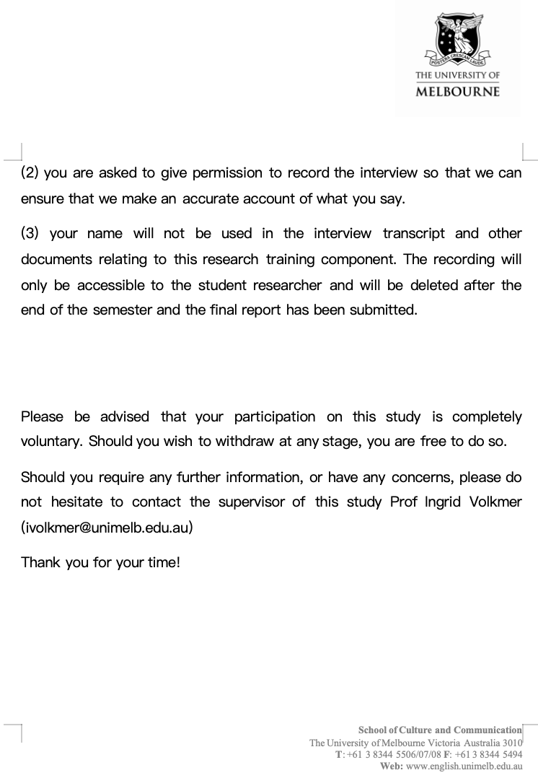

C.Consent form
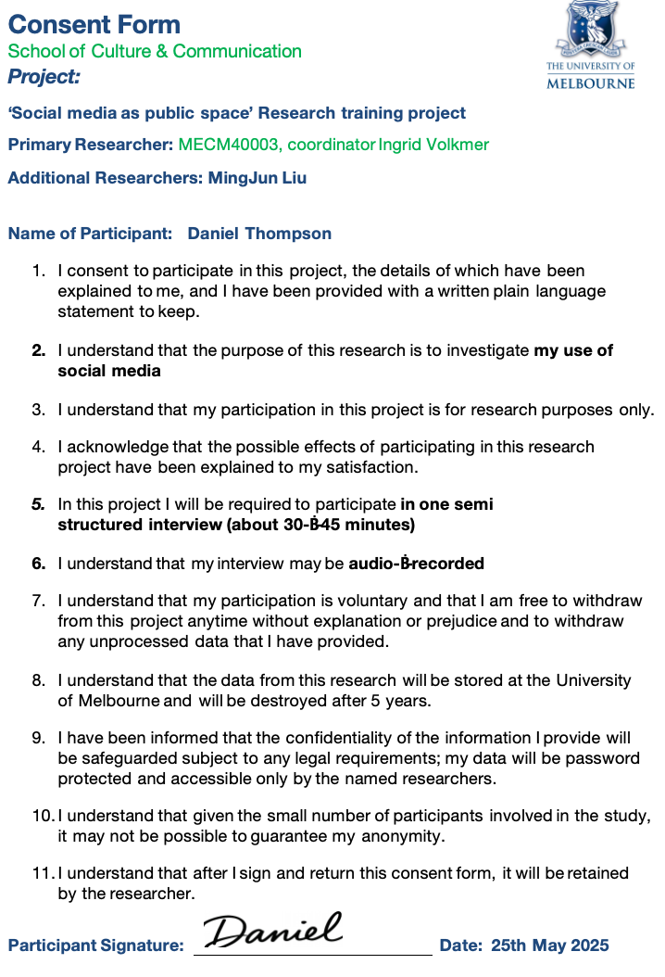

AI content

The Lifeworld and Subjective Meaning-Making
- Habermas’s (1981) lifeworld theory frames communication as embedded within shared cultural horizons and assumptions. In digital contexts, the lifeworld is increasingly mediated, with platforms like X shaping the background through which users interpret credibility, risk, and community. Morimoto and Friedland (2010) argue that politically engaged users do not simply consume media—they live through it. In this affective and mediated lifeworld, fear shapes how users interpret not only content, but the contours of reality itself.

Misinformation, under this lens, is not evaluated solely by facticity but by coherence with emotional and communal logics. As such, content perceived externally as false may still “make sense” when situated within the emotional grammar of a lifeworld structured by fear.

Social Identity, Emotion, and Group Solidarity
- Social Identity Theory (Tajfel & Turner, 1979) explains how individuals form part of their self-concept from group affiliation. In digital communities, emotional expressions such as fear reinforce in-group cohesion and sharpen boundaries against perceived out-groups. Within MAGA-affiliated circles, fear-driven narratives—on election fraud or border insecurity—are not only persuasive but identity-affirming.
Marwick and Lewis (2017) show that misinformation persists not because of factual accuracy, but because it “feels true” within emotionally bonded collectives. This “emotional truth effect” is magnified where trust in institutions is low and symbolic belonging is high—conditions typical of polarised online publics.

Uses and Gratifications: Emotional Needs and Media Practice
- While early U&G research emphasised informational or entertainment motives, contemporary approaches recognise emotion as a core driver of media use. Sundar and Limperos (2013) highlight how digital affordances enable affective gratifications, while Perks and Turner (2019) observe that users often seek content that offers emotional stimulation, relief, or validation. For MAGA users like Daniel, fear-laden content may function not only as political commentary, but as an emotionally meaningful tool for community-building, vigilance, and expressive resistance.

Together, these frameworks demonstrate that misinformation is not merely a matter of distorted facts or ideological manipulation—it must be understood within the affective and social environments that give it meaning. Despite growing literature on either emotion or misinformation, few studies critically examine how fear operates as a lived, emotionally structured logic within politicised digital lifeworlds. This research directly addresses that gap, investigating how one MAGA-aligned user experiences, interprets, and circulates fear as a meaningful—if contested—response to perceived crisis.


Methodology
This study adopts a qualitative, interpretive approach to examine how fear shapes misinformation sharing within MAGA communities on X (formerly Twitter). Rather than pursuing generalisable claims or causal explanations, it seeks to uncover the subjective logic, affective motivations, and meaning-making processes embedded in one user’s digitally mediated lifeworld.
The research is grounded in Lifeworld theory (Habermas, 1981), which conceptualises everyday communication as structured by shared cultural assumptions and emotional orientations. In a platform-saturated media landscape, environments like X do more than deliver information—they shape emotional perception, identity boundaries, and moral urgency. This framework is supported by Papacharissi’s (2015) Affective Publics, which explains how emotions mobilise digital publics; Social Identity Theory (Tajfel & Turner, 1979), which reveals how in-group cohesion is emotionally maintained; and Uses and Gratifications theory (Sundar & Limperos, 2013), which offers insight into affect-driven media engagement.
Data were collected through a semi-structured, in-depth interview (n=1) with a purposively selected participant: a 25-year-old U.S. postgraduate student, politically conservative, and an active user embedded in MAGA-aligned X communities. The interview was conducted via Zoom in 25th May 2025 and lasted approximately 45 minutes. This format allowed both thematic consistency and flexibility to follow the participant’s narrative, particularly around emotional responses, misinformation beliefs, and sharing practices.
Guided by a hermeneutic framework, the interview was transcribed verbatim and analysed using a three-level interpretive strategy: (1) general experience and affective logic, (2) linguistic and narrative nuances, and (3) emergent subjective themes. As Kvale and Brinkmann (2009) argue, qualitative interviews are uniquely suited to uncover how individuals assign meaning to complex emotional realities, especially within politicised media environments.
This single-case design does not aim for statistical representativeness, but rather for depth and contextual richness. Ethical approval was obtained, and informed consent was secured from the participant, whose identity has been anonymised in all materials and transcripts.

Interpretation

Level 1: Overall Experience and Practice
At a broader level, Daniel’s engagement with X (formerly Twitter) exemplifies a deeply affective mode of media use, where fear operates not as a disabling emotion but as a structuring force for perception, action, and group identity. Drawing on Habermas’s concept of the lifeworld, X functions in Daniel’s everyday life not merely as a tool for communication, but as a social and symbolic environment where meaning is continually produced and re-affirmed.
Daniel recalls joining X during the 2016 U.S. election, attracted by its immediacy and perceived authenticity: “finally, here’s a place where the truth isn’t being twisted.” This language highlights his dissatisfaction with institutional media and suggests that X offers something more emotionally resonant—what Uses and Gratifications theory would call “affective utility.” He does not seek objective information alone; he seeks a space where emotional validation, group solidarity, and ideological clarity are available and reinforced.
His everyday interaction with X centers on topics like election integrity, border control, and freedom of speech. But these are not treated as mere policy concerns—they are imbued with existential weight. He describes the platform as “a frontline in a battle for the country’s soul,” revealing a perception of participation that is urgent, moral, and emotional. This framing reflects Papacharissi’s theory of affective publics: Daniel and his MAGA peers form a network not around shared facts, but around shared affect—especially fear, urgency, and moral threat.
Notably, Daniel does not describe fear as incapacitating. On the contrary, he says, “that fear doesn’t freeze me—it sharpens me.” Emotion, in his lifeworld, is not irrational—it is clarifying. It legitimizes attention, reinforces group coherence, and justifies action. His evaluative framework prioritizes “internal logic” and community alignment over institutional credibility: “Believability… is about whether it reflects what the people I trust are also seeing.” This view exemplifies a kind of epistemic collectivism, where truth is emotionally and socially co-produced within a like-minded network—closely aligned with Social Identity Theory.
The affective atmosphere of X is crucial to this process. Daniel describes the tone as “intense—angry, frustrated, and sometimes fearful,” yet he embraces this intensity. Rather than labeling it toxic, he frames it as evidence of genuine civic alertness: “It’s like we’re all trying to sound the alarm.” The emotional saturation of the platform is not a side effect but a feature—it confirms the seriousness of the moment and sustains his sense of being part of a vigilant public.
Crucially, even misinformation is reframed through this affective logic. Daniel notes, “when something gets fact-checked… that actually raises my interest.” In his view, suppression by institutional sources acts as a signal of deeper, concealed truths. This epistemic reversal resonates with Morimoto and Friedland’s (2010) notion of a fragmented lifeworld shaped by distrust in dominant systems, where individuals navigate meaning through emotional resonance and peer affirmation.
Daniel’s engagement with X, then, is not just driven by content—it is structured by emotional dynamics embedded in his lifeworld. Fear, for him, is not a passing feeling but a lens through which reality is interpreted and action is compelled. X becomes both mirror and amplifier: it reflects his fears, while also intensifying them into a logic of participation, sharing, and vigilance.
In sum, Daniel’s media use is existential in that it fulfills core emotional and identity needs. It provides not only information but orientation, not just opinions but a sense of purpose. Through emotionally-driven participation on X, Daniel affirms his role within a broader struggle—not only to reveal “the truth,” but to protect what he perceives as the essence of America itself. This affective attachment renders X more than a digital platform—it becomes a site of emotional home-making and symbolic defense.

Level 2: Nuances of Practice
A close reading of Daniel’s language reveals a discursive world built on emotionally saturated metaphors that sustain a lived experience of vigilance and moral duty. His repeated use of phrases like “wake up,” “the ground is shifting,” “battle for the country’s soul,” and “stay alert” transforms political life into a state of constant alarm. X is described not as a platform, but as a “frontline”—a metaphor that positions Daniel as an active combatant in a symbolic war. This aligns with Papacharissi’s notion of affective publics, wherein publics coalesce through emotional urgency rather than rational deliberation.
These metaphors function beyond expression—they shape epistemology. When Daniel says, “if something gets fact-checked… that actually raises my interest,” he reframes suppression as validation. In his interpretive logic, emotional resonance and community affirmation override empirical verification. This inversion of epistemic trust suggests a lifeworld where “truth” is not institutionally defined but emotionally confirmed—a notion that mirrors Morimoto and Friedland’s insights on media sense-making in uncertain environments.
Another discursive pattern is his frequent invocation of “they”—a shadowy antagonist who “doesn’t want you to see this” or is “eroding our rights.” This externalized threat constructs clear symbolic boundaries between an in-group of truth-tellers and an out-group of suppressors. Consistent with Social Identity Theory, this boundary-making fosters belonging and purpose. Fear here is both a diagnostic and a mobilizing force.
Daniel’s sharing practices also embody an emotionally strategic intent. He reposts content to “jolt” viewers, to make them “stop scrolling” and confront uncomfortable realities. As Uses and Gratifications theory suggests, emotional intensity—not factuality—is often the core driver of engagement. Daniel’s aim is affective disruption, not persuasion.
Lastly, emotional expressions like “validation,” “confirmation,” and “resonance” suggest a lifeworld where trust is communally negotiated. Truth emerges not from institutional credibility but from shared emotional logic. What appears as misinformation to outsiders is, within this affective lifeworld, an emotionally coherent and morally urgent message.

Level 3: Subjective Theme Based on Subjective Experience
At the core of Daniel’s narrative lies a defining subjective theme: fear as a moral imperative. Unlike typical portrayals of fear as destabilizing or irrational, Daniel positions it as ethically necessary—a signal of awareness, urgency, and civic responsibility. When he says, “Fear doesn’t freeze me—it sharpens me,” he expresses not vulnerability, but a belief that fear is a clarifying force that reveals hidden dangers and compels action.
Within this lifeworld, fear operates not as emotional noise, but as moral signal. Daniel views his emotional reactions as evidence of heightened perception, not weakness. His insistence on “waking people up” and “breaking the spell of complacency” positions him as an emotional intermediary—someone who converts affect into awareness. In this framework, fear becomes a tool of civic pedagogy: by sharing content that unsettles or alarms, Daniel believes he helps others “see more clearly.” This transforms emotion into action, and sharing into moral instruction.
This emotional logic also resists dominant narratives around misinformation. Daniel explicitly rejects the idea that fear-induced sharing reflects gullibility. Instead, he frames it as principled defiance: “Sometimes fear isn’t dysfunction. Sometimes it’s a sign that people are finally waking up.” In this reversal, fear becomes evidence of integrity, not manipulation—a marker of those who are emotionally attuned to political decay. Here, affect becomes epistemic authority.
Further, Daniel’s mistrust of institutional verification underscores a shift from procedural truth to affective coherence. What matters is not whether something is officially verified, but whether it “feels real,” whether it aligns with his lived sense of betrayal and loss. Emotion becomes a diagnostic tool—a way of detecting what official narratives suppress. As such, misinformation, within his lifeworld, is reclassified as emotionally truthful even when factually contested.
In sum, Daniel’s emotional worldview is not passive—it is strategic, pedagogical, and collectivist. Fear is not just felt, but deployed—as a mechanism of community bonding, moral alarm, and digital resistance. His actions on X are thus not simply expressive, but performative: they constitute a lifeworld in which emotion is political, misinformation is recontextualized, and fear becomes a shared grammar of meaning and belonging.

Conclusion
This research investigated how fear—as both an affective experience and a social mechanism—shapes the sharing of misinformation within MAGA communities on X. Drawing on Lifeworld theory and a qualitative case study, it revealed how digital environments saturated with emotion mediate users’ perceptions of truth, group identity, and civic responsibility.
Rather than paralyzing, fear was experienced by the participant as emotionally clarifying. It served as both an internal response to perceived political decay and an externalised moral imperative to alert others. Within this framework, misinformation was not judged by conventional standards of factuality, but by its alignment with an affective logic: whether it resonated with lived experience, confirmed group values, and mobilised action. Sharing such content became a performative act of care, solidarity, and symbolic resistance.
These insights underscore the relevance of Lifeworld theory in understanding digitally mediated meaning-making, where truth is not merely processed cognitively but constructed emotionally. They also reinforce Papacharissi’s (2015) concept of affective publics, in which emotion structures not just expression but political belonging. Together, these frameworks challenge rationalist misinformation models that isolate belief from the affective and social contexts in which it circulates.
Though limited to a single respondent, the study provides a thick description of how political emotions like fear function as epistemic and mobilising tools in digital culture. It opens space for future research to compare how other ideological groups emotionally legitimise contested narratives in similarly networked lifeworlds.
Ultimately, confronting the misinformation crisis requires more than content correction—it demands an engagement with the affective infrastructures that sustain emotional truths. Fear, far from being a distraction from reason, may be the very terrain on which belief and participation are formed in contemporary digital publics.

